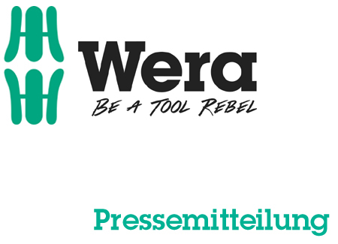

Date: 06 March 2016
Editor: Klaus Teders

The new Wera Bit-Check family:

All new for 2016!

Completely new Bit-Check family design / Significant improvement in efficiency / Compact and light Bit-Checks for shirt and trouser pockets / Tool finder for fast location of bits / Coloured sleeves for different bit profiles / Stamping for easy differentiation between sizes / Bit Safes with up to 61 parts in a surface-friendly, compact textile box /

Cologne / Wuppertal. Wera has long had many bit sets in its extensive product range, and they are well-known across the world. But is Wera happy with the standard it itself set for market-leading bit sets? Of course not. Wera is challenging everything in 2016, turning it all upside down…

Honey – I shrunk the Bit-Checks!
The product development team at Wera have shrunk Bit-Check sets, to make them even more compact and light than the previous generation. Product design was updated at the same time, adapting to the new Wera brand identity. The result is a lightweight companion ideal for on-the-go jobs, slipping easily in a shirt or trouser pocket. The multi-component material used to produce the new Bit-Check is also convenient: hard basic materials ensure robustness, while soft material enables safe clamping of the bits yet ensure easy removal. To set up on-site, the Bit-Check merely has to be opened - with bits standing tall above the case for easy removal.

It’s all so colourful here
Wera has also simplified locating the bit you need from within a Bit-Check. The “Take it Easy” tool finder system now provides a burst of colour in sets from the Impaktor, Stainless, BiTorsion and Diamond ranges, with coloured sleeves clearly allocating bits to a profile. Red indicates a PH tip, black for PZ, green for Torx, blue for hexagon socket and yellow for slotted screws. Additional stamping ensures simple differentiation between sizes. Thanks to this high-impact visual indicator, the required bit can be found in a matter of moments - even in large, well-equipped bit sets.

The range of 65 Bit-Checks has a simple structure, featurising a revised naming system – a ‘Bit-Check 6 PH Diamond 1’, for example, is a 6pc set featuring Phillips Diamond bits, and is the first Bit-Check in that product group. The ‘Bit-Check 12 Wood 2’ is a 12pc version featuring bits ideal for screw-driving into wood, and is the second Bit-Check in that product group. This serves as simple differentiation between similar Bit-Checks,

Five Bit-Safe sets round off the range, now coming in surface-friendly, compact textile boxes. A brand new display that makes it easy to find the right Bit-Check on the first look is also available to retailers.

More information:

Wera Werk Hermann Werner GmbH & Co. KG

Korzerter Straße 21-25, 42349 Wuppertal / Germany

Phone: +49 (0)2 02 / 40 45 311, Fax: 40 36 34

e-Mail: info@wera.de, Internet: www.wera.de

Wera Tools (UK) Ltd

Units 1-2 McGregors Way, Turnoaks Business Park,

Chesterfield. S40 2WB

Tel: 01246 277756 Fax: 01246 273335

email: queries@wera-tools.co.uk web: www.wera-tools.co.uk

Search @WeraToolsUK on Social Media

TECHNO PRESS

Captions:

01_Bit-Check_6_PZ_Diamond_1
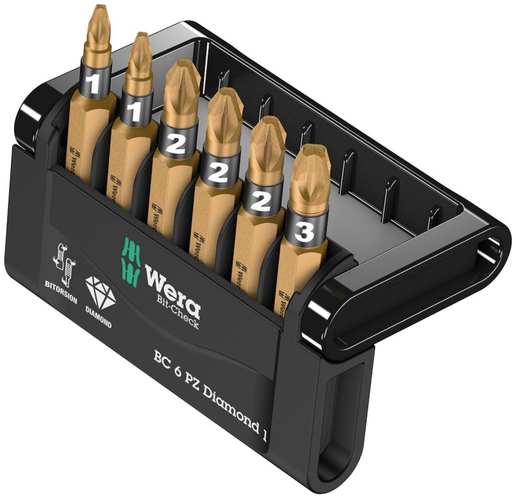
The new BC 6 Bit-Checks by Wera include six bits and are a compact and leight-weight companion even on mobile assignments, as they even fit into a shirt pocket.

02_take_it_easy_bits
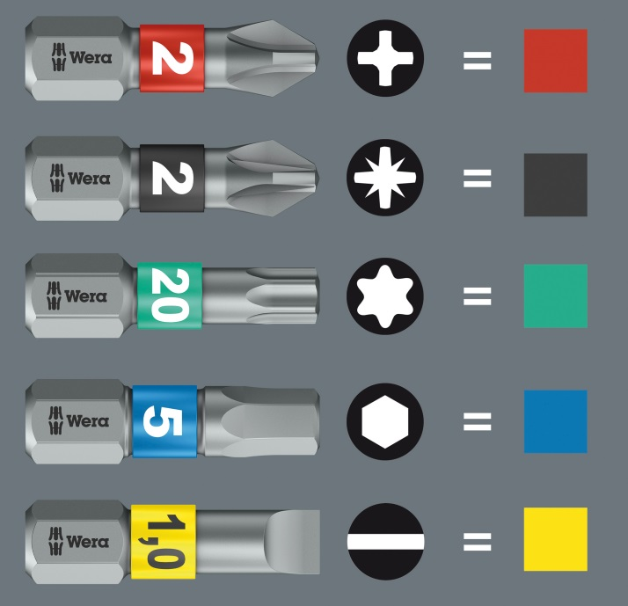
All bits in the Bit-Checks are equipped with the new “Take it Easy” tool finder: coloured sleeves allocate the bits clearly to a certain profile and stamping ensures fast location of the sought-after size.

03_Bit_Safe_61_BiTorsion
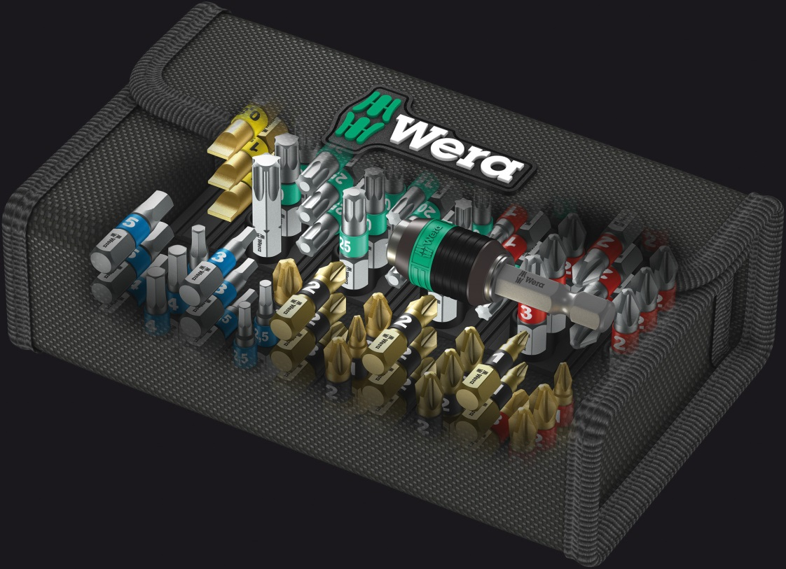
The new bit safes provide the user with an up to 61-piece assortment of bits and holders in a surface-friendly, compact textile box.

Pictures: Wera Werk Hermann Werner GmbH & Co. KG

Press contact:

Wera Werk  Hermann Werner GmbH & Co. KG  Detlef Seyfarth  Korzerter Straße 21-25  42349 Wuppertal / Germany  Phone: +49 (0)2 02 / 40 45 311  Fax: +49 (0)2 02 / 40 36 34  e-Mail: info@wera.de | TECHNO PRESS  Presseinformationsdienst  (Press Information Service)  Wolfgang D. Riedel  P. O. Box 10 04 49  42004 Wuppertal / Germany  Phone: +49 (0)2 02 / 9 70 10 0  Fax: +49 (0)2 02 / 9 70 10 50  e-Mail: info@technopress.de
Released for printout, copy requested

