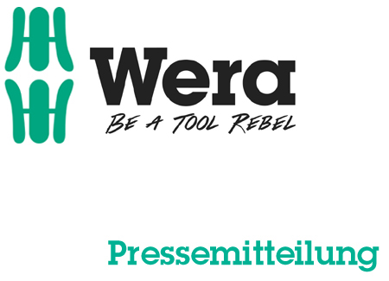

Date: 06 March 2016
Editor: Klaus Teders

Zyklop Hybrid by Wera:

One ratchet – many benefits

Low-weight, slender and strong ratchet / Ball-lock for a secure holding of sockets and accessories / Kraftform handle specially optimised for pressure and tensile loads / Handle extension for even greater force transmission / Available as a 2pc set with extension, or in a socket set /

Cologne / Wuppertal. The new Zyklop Hybrid ratchet is one of the highlights of Wera’s appearance at the International Hardware Fair 2016. As the name indicates, a selection of great features are combined together in this ratchet, making it truly all-purpose and ideal for a huge variety of applications.

A ratchet with hybrid benefits
During development of Zyklop Hybrid, Wera designers pursued the objective of combining important ratchet benefits into one single tool. A lightweight yet robust ratchet has emerged, with an ergonomic Kraftform handle, slender head geometry and a long handle, plus an additional extension option. Zyklop Hybrid combines robustness, slenderness and a low weight into a single multi-purpose tool.

Simple and safe ratchet work
The reversible ratchet with 72 fine-pitched teeth has a low return angle of just 5°. This short stroke allows fast and precise work in all installation positions, including in cramped working environments. A ball lock securely holds sockets and attachments, ensuring reliable safety during use.

The multi-component handle is based upon the tried and tested design of the unique Wera Kraftform handle, and has been specially optimised for pressure and tensile loads. This enables ergonomic and safe working at the same time. Compared to conventional ratchets, Zyklop Hybrid features an ample overall length for a high degree of force transmission. When even greater force needs to be transferred, the additional extension can also be locked into the end of the handle, making Zyklop Hybrid extra-long.

Zyklop Hybrid is available as a 2pc ratchet and extension handle set, and as part of a socket set – which features a Zyklop Hybrid ratchet, handle extension, ten sockets (with width across flats from 10 to 19mm) and a socket extension with free-turning sleeve, for lightning-fast tightening or loosening of screws and nuts. The socket set is clearly arranged and held compactly in the new-style Wera textile box, which robustly protects the contents, even if dropped.

More information:

Wera Werk Hermann Werner GmbH & Co. KG

Korzerter Straße 21-25, 42349 Wuppertal / Germany

Phone: +49 (0)2 02 / 40 45 311, Fax: 40 36 34

e-Mail: info@wera.de, Internet: www.wera.de

Wera Tools (UK) Ltd

Units 1-2 McGregors Way, Turnoaks Business Park,

Chesterfield. S40 2WB

Tel: 01246 277756 Fax: 01246 273335

email: queries@wera-tools.co.uk web: www.wera-tools.co.uk

Search @WeraToolsUK on Social Media

TECHNO PRESS
Captions:

01_Wera_Zyklop_Hybrid_Set
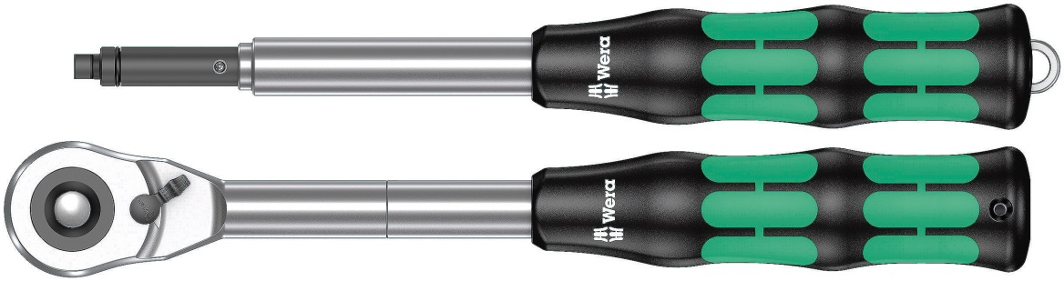
The Zyklop Hybrid ratchet is light-weight and robust at the same time. It offers slender head geometry, an ergonomic Kraftform handle and an additional extension that is simply inserted and locked in the end of the handle.

02_Wera_Zyklop_Hybrid_Box
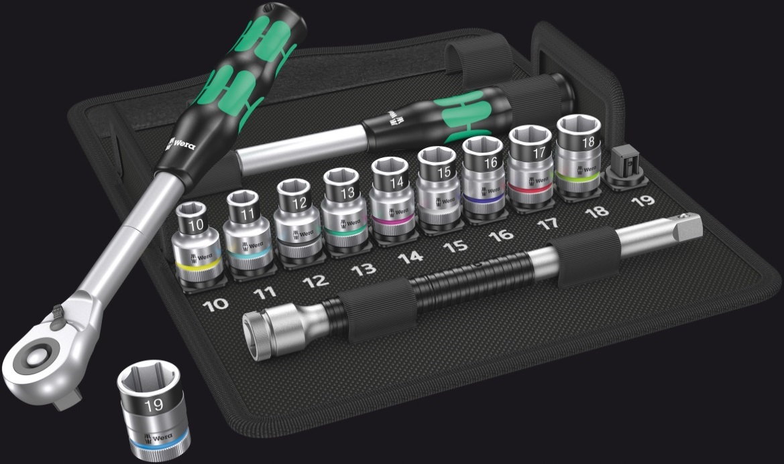
The Zyklop Hybrid ratchet set consists of a ratchet, a handle extension, a socket extension with fast-turning sleeve and ten sockets with width across flats of 10 to 19 mm. It is clearly arranged and accommodated in a compact textile box.

Pictures: Wera Werk Hermann Werner GmbH & Co. KG

Press contact:

Wera Werk  Hermann Werner GmbH & Co. KG  Detlef Seyfarth  Korzerter Straße 21-25  42349 Wuppertal / Germany  Phone: +49 (0)2 02 / 40 45 311  Fax: +49 (0)2 02 / 40 36 34  e-Mail: info@wera.de | TECHNO PRESS  Presseinformationsdienst  (Press Information Service)  Wolfgang D. Riedel  P. O. Box 10 04 49  42004 Wuppertal / Germany  Phone: +49 (0)2 02 / 9 70 10 0  Fax: +49 (0)2 02 / 9 70 10 50  e-Mail: info@technopress.de
Released for printout, copy requested

