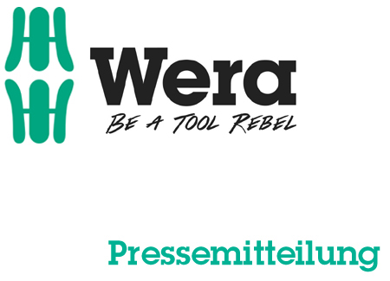

Date: 06 March 2016
Editor: Klaus Teders

Innovative way to make your work easier:

Sockets and bit sockets with holding function and “Take it Easy” tool finder

Accessories programme expanded for Zyklop ratchets / Screwdriver and bit holding function transferred to sockets / Equally well suited to manual operation and machine operation / “Take it easy” tool finder: coloured identification marking to find the right tool quickly / Available as an individual item or as a set /

Cologne / Wuppertal. Wera, the screw-driving tool specialist from Wuppertal, presented sockets and bit sockets with an innovative holding function at the International Hardware Fair 2016 in Cologne. This expands the accessories programme for the Zyklop ratchet range, rounding it off nicely to meet end user requirements.

A secure hold
For some time, Wera have sold bits and screwdrivers with a screw-holding function, and in 2016 the product development team accepted the challenge to transfer this useful benefit to sockets. The new Zyklop sockets and bit sockets with integrated holding function prove that they have succeeded: they hold screws or nuts securely on, or in, the tool. Thus screw-driving can be carried out quickly and effectively even in areas that are difficult to access, or when the second hand cannot be used to thread or hold the screw.

For manual and machine operation
Zyklop sockets are equally well suited to manual or machine operation (non-impact), saving the user from having to invest in two different sets. As a result they are equipped for nearly all screw-driving applications with just one socket set.

Show your true colours
Wera shows its colourful side with these new sockets and bit sockets; they are all equipped with the new “Take it Easy” tool finder. This colour-coding system means that sizes are indicated by the coloured band on each tool. Sizes are also illustrated by the easy to read stamp, with the two combining to ensure it is much easier to find the right tool.

Zyklop bit sockets from Wera are available as an individual item or in one of 3 sets - specially compiled to include either Torx® profile bit-holding sockets, hexagon bit-holding sockets or bolt-holding sockets. Each comes in a new-style Wera textile box.

More information:

Wera Werk Hermann Werner GmbH & Co. KG

Korzerter Straße 21-25, 42349 Wuppertal / Germany

Phone: +49 (0)2 02 / 40 45 311, Fax: 40 36 34

e-Mail: info@wera.de, Internet: www.wera.de

Wera Tools (UK) Ltd

Units 1-2 McGregors Way, Turnoaks Business Park,

Chesterfield. S40 2WB

Tel: 01246 277756 Fax: 01246 273335

email: queries@wera-tools.co.uk web: www.wera-tools.co.uk

Search @WeraToolsUK on Social Media

TECHNO PRESS
Captions:

01_Wera_Bit-Socket_Holding Function
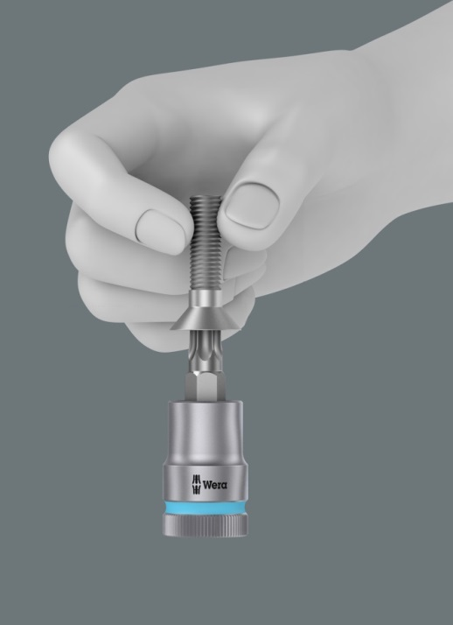
Wera’s new sockets and bit sockets have an innovative holding function that holds screws securely on the tool.

02_Wera_Socket Set
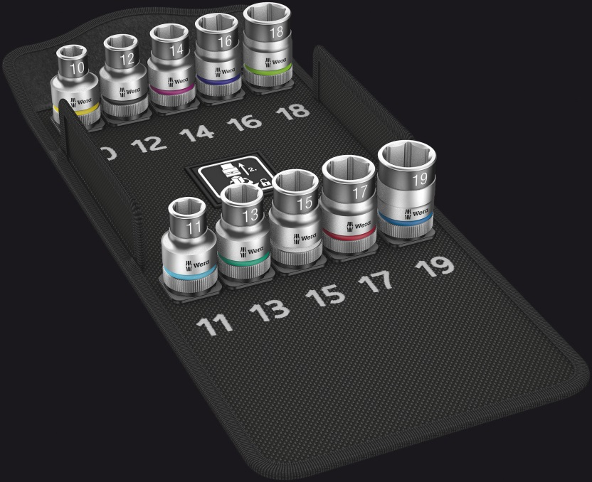
All sockets and bit sockets are equipped with the new “Take it Easy” tool finder. This makes it significantly easier to find the right tool.

Pictures: Wera Werk Hermann Werner GmbH & Co. KG

Press contact:

Wera Werk  Hermann Werner GmbH & Co. KG  Detlef Seyfarth  Korzerter Straße 21-25  42349 Wuppertal / Germany  Phone: +49 (0)2 02 / 40 45 311  Fax: +49 (0)2 02 / 40 36 34  e-Mail: info@wera.de | TECHNO PRESS  Presseinformationsdienst  (Press Information Service)  Wolfgang D. Riedel  P. O. Box 10 04 49  42004 Wuppertal / Germany  Phone: +49 (0)2 02 / 9 70 10 0  Fax: +49 (0)2 02 / 9 70 10 50  e-Mail: info@technopress.de
Released for printout, copy requested

