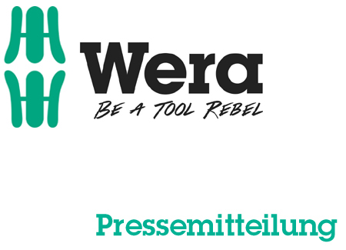

Date: 06 March 2016
Editor: Klaus Teders

“Take it Easy” makes life simpler:

Find the right tool, fast!

New Wera “Take it Easy” tool finder / Coloured sleeves clearly indicate the profile type of screwdriver bits / Additional stamping for easy size differentiation / Tool finder also launched for wrenches, sockets & L-keys /

Cologne / Wuppertal. Most professionals are very aware of this common problem: the search for the suitable bit taking longer than the actual screwdriving process. But not any more! Wera, the German screw-driving tool specialist, presented their new “Take it Easy” tool finder system at the Cologne International Hardware Fair 2016.

Wera plays with colours…
The Tool Rebels at Wera consistently push to challenge accepted standards – with the objective of making users’ lives safer and ‘full of joy’. After turning this game-changing thought process towards ratchets and wrenches, Wera returned to a core product range – screwdriver bits. But what can possibly be done to improve upon the current standards for bits?

Simple – easier bit searches; something the new “Take it Easy” tool finder system makes super-easy. Coloured sleeves clearly indicate bit profiles, simplifying searches for the tip that matches your screw. For example, a red sleeve indicates a Phillips (PH) bit. Additional stamping ensures easy differentiation between sizes. With immediate effect, all premium Wera ranges (including Impaktor, Diamond, BiTorsion and Stainless) are adopting this system, making it easier and faster to find the right tool.

New “Take it Easy” tool finder system…
But that’s not all! The product development team were on a roll –transferring the tool finder concept to other Wera assembly tools for screws and nuts. Jaw wrenches, sockets, bit sockets and L-Keys have now been placed under the “Take it Easy” umbrella. In addition to existing size stamps, jaw wrenches receive a coloured bar for visual differentiation between sizes. On the sockets and bit sockets, an additional colour zone next to the stamping clarifies their size.

To keep things as easy as possible, Wera followed a simple rule when assigning colours to these tools, that drive hexagon head screws, socket head screws and Torx® screws: same size - same colour. For example, for jaw wrenches and sockets, green symbolises a width across flats of 13 mm. As a result, the size of each tool can clearly be seen at a glance.

More information:

Wera Werk Hermann Werner GmbH & Co. KG

Korzerter Straße 21-25, 42349 Wuppertal / Germany

Phone: +49 (0)2 02 / 40 45 322, Fax: 40 36 34

e-Mail: info@wera.de, Internet: www.wera.de

Wera Tools (UK) Ltd

Units 1-2 McGregors Way, Turnoaks Business Park,

Chesterfield. S40 2WB

Tel: 01246 277756 Fax: 01246 273335

email: queries@wera-tools.co.uk web: www.wera-tools.co.uk

Search @WeraToolsUK on Social Media

TECHNO PRESS
Captions:

01_take_it_easy_bits
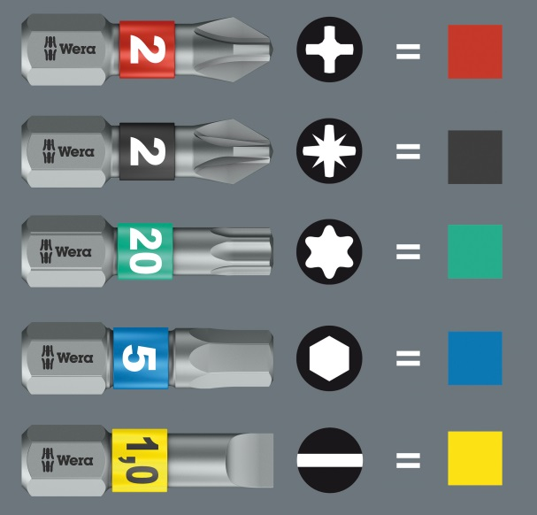
The Wera "Take it Easy" tool finder allocates bits to a certain profile by means of coloured sleeves. Additional size stamping serves to differentiate between the profiles. This makes it even faster and easier to find the matching bit.

02_Take_it_easy_hexagon head_grey
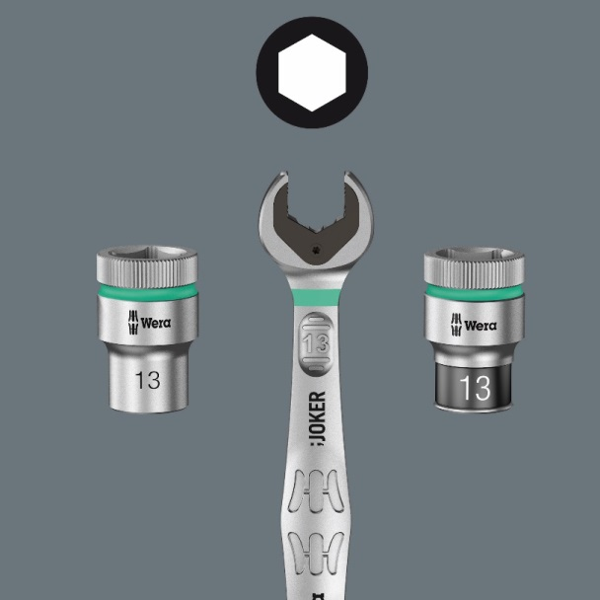
The "Take it Easy" tool finder colour coding has also been transferred to jaw wrenches, sockets, bit sockets and offset screwdrivers. The green marking is easy to see and in this case stands for a width across flats of 13 mm.

Pictures: Wera Werk Hermann Werner GmbH & Co. KG

Press contact:

Wera Werk  Hermann Werner GmbH & Co. KG  Detlef Seyfarth  Korzerter Straße 21-25  42349 Wuppertal / Germany  Phone: +49 (0)2 02 / 40 45 322  Fax: +49 (0)2 02 / 40 36 34  e-Mail: info@wera.de | TECHNO PRESS  Presseinformationsdienst  (Press Information Service)  Wolfgang D. Riedel  P. O. Box 10 04 49  42004 Wuppertal / Germany  Phone: +49 (0)2 02 / 9 70 10 0  Fax: +49 (0)2 02 / 9 70 10 50  e-Mail: info@technopress.de
Released for printout, copy requested

